VA November Baseline Storefront AB test result Update as of 2017-11-29:

Since the configuration ID got reset on Nov 24th, we are on the fifth day of the Storefront Test. The Revenue per Visitor of the Test Storefront is consistently lower than the Control Storefront. Although the test Storefront didn’t perform well at baseline, it did generate way more transactions and almost three times as high revenue per visitor during the Promo period in October. The new Storefront will be rolled out today, along with the new Call Centre feature.

1. The Revenue per Visitor of the Test Storefront was **-38% lower** than the Control Storefront.
2. The conversion rate of the Test Storefront was **-17% lower** than that of the Control Storefront
3. The ATS of the Test Storefront was **-30% lower** than that of the Control Storefront

You can find the report here,

<https://data.points.com/#/views/VA_StorefrontTest_Nov2017BaselineAfterReset/Story>

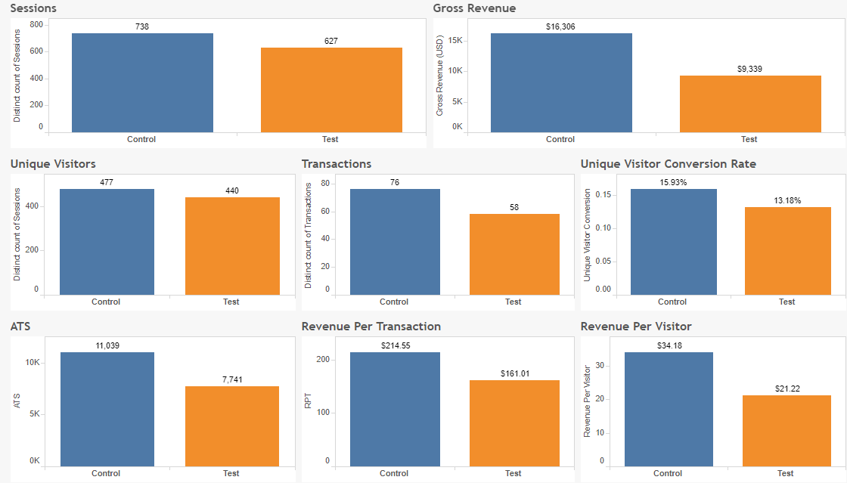

The entire Storefront Test during baseline ran from November 1st to November 29th,

1. The Revenue per Visitor of the Test Storefront was **-19% lower** than the Control Storefront.
2. The conversion rate of the Test Storefront was **-7% lower** than that of the Control Storefront
3. The ATS of the Test Storefront was **-15% lower** than that of the Control Storefront
4. Neither ATS nor Conversion reached statistical significance